ALICK TIPOTI - SYDNEY BIENNALE
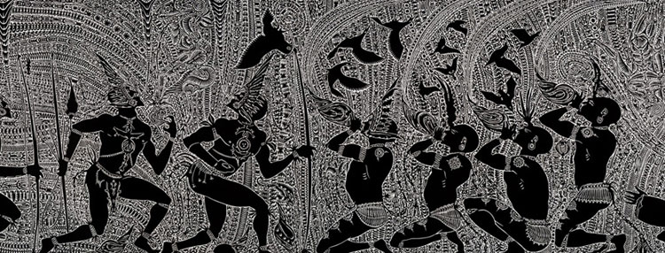
 | Alick Tipoti, first Torres Strait Islander artist to be selected for the Biennale of Sydney  Alick Tipoti has been selected to participate in this year’s Sydney Biennale and is the first Torres Strait Islander artist to be chosen in its 39 year history.  His inclusion in the Biennale is another milestone in the artist’s rapidly growing reputation.  In a review of the artist’s most recent exhibition at Canopy Artspace in Cairns, John McDonald, the influential Sydney Morning Herald art critic, described him as ‘… one of the rising stars of Australian Art.’  Tipoti’s inclusion in the Indigenous Art Triennial that opens at the National Gallery of Australia in May this year supports McDonald’s view. These exhibitions come on top of recent public art commissions and the large body of work that showed in the recent ground breaking Torres Strait Islands exhibition at the Gallery of Modern Art in Brisbane last year.  The artist is guided by the spiritual traditional and cultural practices of his people, the Maluyligal of Zenadh Kes (Torres Strait). He is fluent in the local languages and believes that language is the core of all the world’s cultures and maintains that song, dance and the visual arts all evolve from the centrepiece of language.  At home he is known as Zugub which is a name for the tall spiritual ancestors of the past who were able to control weather patterns and transform themselves into anything they desired. The artist says he connects with the Zugubal who have instructed him on the proper ways of his cultural traditions and have guided him in interpretating their words into his art practice.  Tipoti’s work chosen for the Sydney Biennale is a monumental 8 metre x 1.2 metre linocut titled, ‘Girelal’.  The logistics, artistic and technical expertise in creating such a work is extraordinary. Several experts claim that it is the world’s largest linocut printed from one block on a single sheet of paper.  This lino represents the pinnacle in the evolution of Torres Strait Islander printmaking that is noted for intricate works produced on a massive scale.  ‘Girelal’, translates as dances. It shows the cultural connection between the physical and the spiritual worlds and depicts the stages and sequences of traditional chants and some of the totems and stories that are danced about.  Tipoti comes from a line of dance masters and choreographers so therefore feels compelled to continue this heritage. With the blessing of his elders and cultural mentors, he has composed and choreographed chants not sacred but spiritual that are associated with the linocut.  The theme of this year’s Biennale is rooted in storytelling. This and dance are the vehicles that have been used for thousands of years for the passing down of all Torres Strait Islander knowledge and culture. Imbedded in Tipoti’s linocuts is a wealth of information, some sacred that cannot be shared but other that provides an absorbing and fascinating insight into the incredibly rich but little known culture of the Torres Strait Islands.  Visit the Biennale website http://bos18.com/
  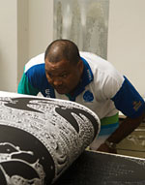
  Alick inspecting the
  Sydney Biennale linocut
  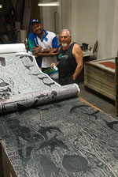
  Alick Tipoti and Master Printmaker Theo Tremblay proofing Girelal
  
  Alick Tipoti printing the Sydney Biennale work,’Girelal’

